**MEETING NOTICE**

**EXECUTIVE COMMITTEE**

There will be a meeting of the Executive Committee of the North Central Florida Regional Planning Council on May 24, 2012. The meeting will be held at the Holiday Inn Hotel & Suites, 213 Southwest Commerce Boulevard, Lake City, Florida at 6:00 p.m.

(Location Map on Back)

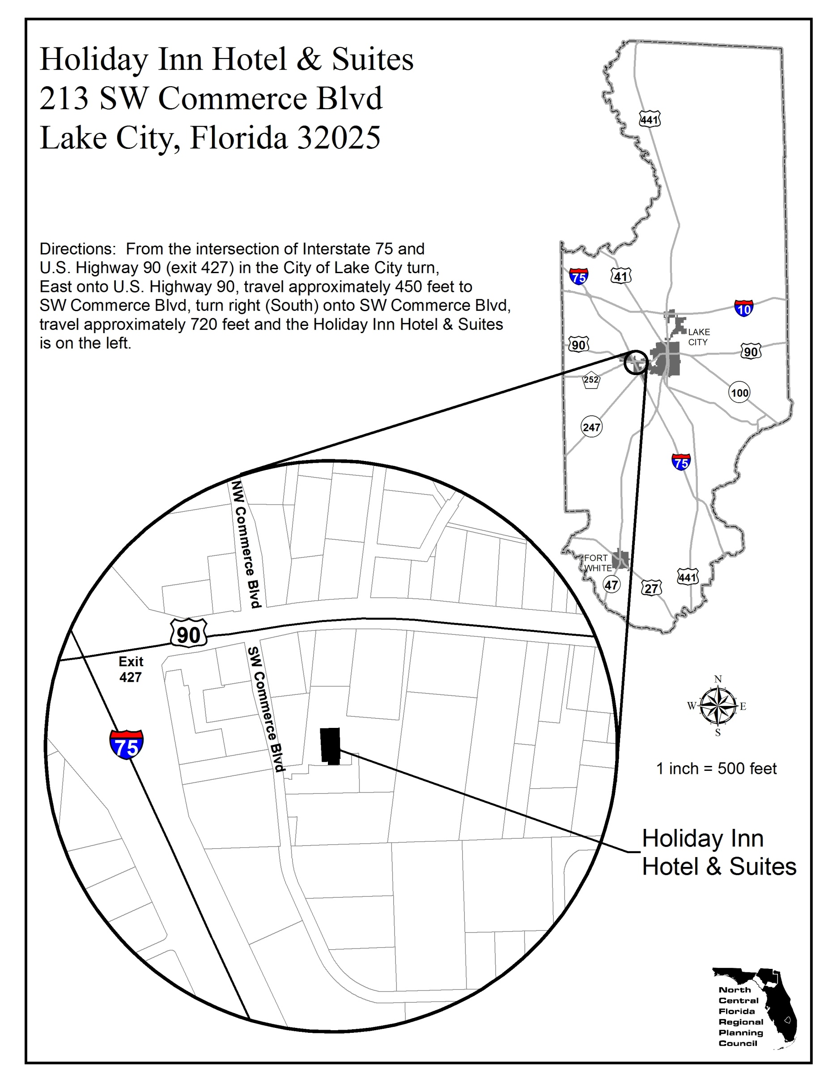

**AGENDA**

**EXECUTIVE COMMITTEE**

Holiday Inn Hotel & Suites May 24, 2012

Lake City, Florida 6:00 p.m.

**Page**

* I. APPROVAL OF MINUTES - April 26, 2012 5

II. CONTRACTS AND APPLICATIONS

* A. Agreement with Florida Division of Emergency Management

for Local Emergency Planning Committee, Fiscal Year 2012-13 7

* B. Agreement with Florida Division of Emergency Management

for Hazardous Materials Emergency Preparedness - Fiscal Year 2012-13 9

* C. Purchase Order with Apalachee Regional Planning Council to Assist with

Evaluating Statewide Hurricane Exercise 11

III. PROGRAM REPORT - None

* IV. GENERAL ADMINISTRATION - Meeting Schedule Program Year 2012-13 13

V. OTHER BUSINESS - Florida Regional Councils Association Policy Board Meeting

Hollywood - August 24, 2012

* See Attachments